|  |  |  |  |  |  |
| --- | --- | --- | --- | --- | --- |
| Date | Dec 6, 2022 | | | Tester Name | Syed Shahabuddin |
| Environment | Penfax - Test | | | Login used |  |
| Operating System | Windows | Version: | Update: | | |
| Software Used | Edge | Version: | Update: | | |
| Select Software | Version: | Update: | | |
| Release version | 22.4.1 | | | | |
| Title | E26.08 | | | | |
| Test Type | Regression | | | | |
| Test Scenario | Fee’s and Instruction origin on Life Cycle Batch generated transactions | | | | |
|  |  | | | | |
| Expected Results | Verify the DAI, interfund and schedule withdrawal instructions created by the life cycle batch should have instruction origin as ' System' & no fee is charged | | | | |
| Pass/Fail | Pass | | | JIRA# | N/A |

Pulled member from one of the previous test cases for the life cycle batch.

SID: 306038

Confirmed that the instruction origin shows as system:

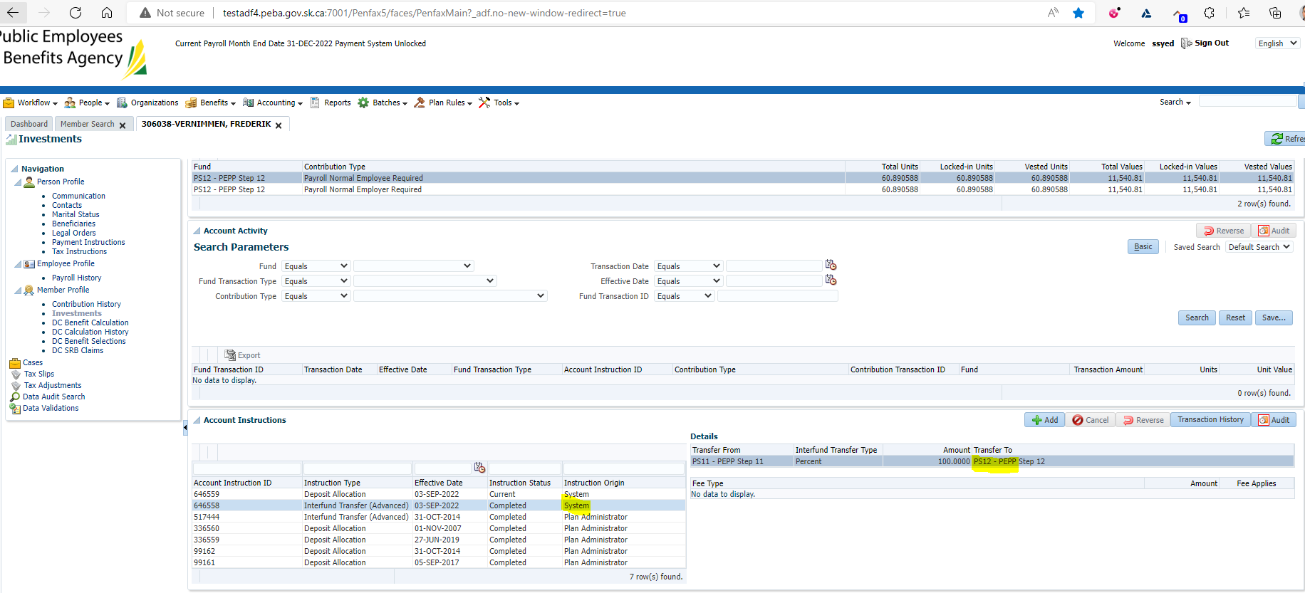

Confirmed there was no fee charged, both under account instructions and under account activity:

